Student Showcase Entry Form

Game Title:
Ta-Ta Mahatta

Contact:
David Dionisio

4715 148th Ave. NE FF-202
Bellevue, WA 98007

Phone: (425) 497-8496
Email: daviddionisio@earthlink.net; ddionisi@digipen.edu

Enrolled at:
Digipen
(425) 558-0299

Enrollment date:
September 1999

Game Description:

Ta-Ta Mahatta puts you in control of cute furry creatures called Ta-Ta. Each Ta-Ta has it’s own unique special abilities to overcome the obstacles found throughout the land. Ta-Ta Mahatta is a mixture of two genres: third person action and puzzle.

Game Credits:

David Dionisio – producer/designer/tech director/programmer/artist
Ted – artist
David R. Clark – musician

Platform and Minimum Requirements:

PC
Windows NT 4.0 or later, Windows 2000
400 MHz IBM or compatible processor
64 MB RAM
Full DirectX 8 compliant 3D accelerated video card with 16MB RAM
DirectX 8.1
100% Windows compatible sound card
Keyboard

Developed and tested on:

PC
Windows 2000
850 MHz Pentium III
128 MB RAM
DirectX 8.1
GeForce 3 64 MB RAM
Keyboard

Game Development Time:

The game is developed as a 2-semester school project. Work on the game started at the first week of September.

The graphics engine of the game is based on the work made by David Dionisio last year. New features include: skeletal animation, particle effects and level display.

The game has been on developed for 3 months. The developer plans to finish the game by the end of this year.

Website:
No website at the moment.

Game Development Location:

The game was developed in Washington, USA and is in English.

Biography:

David Dionisio
Age: 20
Place of birth: Philippines

Time passed and David Dionisio had grown restless in Digipen. Failure had gotten into David Dionisio’s nerves. Many were unworthy of shedding the visions of David Dionisio to light. But for every failure, there is a lesson and every lesson had struck David Dionisio a thousand times and more.

Three years of blood and sweat, David Dionisio’s power had grown immensely. Experience with graphics engine (both 2D/3D), digital arts, 3D modeling and fancy-shmancy coding. David Dionisio eagerly waits to test his newfound powers.

David Dionisio is now certain of shedding his visions to light. With all the game development tools he prepared and mustered. Along with creativity and artistic skills…what could go wrong?

Game Overview

Genre:

3D third-person action puzzle game

Technology:

“Ta-ta Mahatta” will be a 3D game, using Direct X 8.1. The game will also use a third party sound engine known as BASS. All models in the game were made using an evaluated version of Milkshape 3D.

Story:

In a distant land, far away, lived a peaceful race of cute, industrious little fur balls called “Ta-tas”. Everything was going well for the ta-tas until one day a portal opened and the evil Mushroominoid with his fungi army started taking over the ta-ta land, and turning all the cute furry ta-tas into slaves. All was looking grim, until one day a wise-one told the legend of the white-hero that would have the power to save them. A small group of the most courageous ta-tas decided to set out in the search of the legendary white ta-ta. Using the wise-one’s magical powers and their own wit and bravery, few ta-tas escape the evil clutches of mushrooms and escape on a cloud. Using the cloud as the base, the ta-tas begin their journey of search for the white ta-ta.

Game play Description:

In Ta-Ta Mahatta, the player will be the brains behind the “ta-ta”s attempt to find the white ta-ta. The player will start off on the cloud. The cloud is where the player can choose to play a level or hang around and do interesting activities.

Interesting activities in the cloud includes being able to view the collection of artifacts the player has found throughout the game. These are just for viewing pleasure. The player can also talk to the Wise-Ta who will give special advice in the game. The player can also play unlocked mini-games in ‘Ta-Vern’ located within the cloud.

The player can choose to play a level by entering the mysterious ‘Level Select’ house. Once inside the house, the player can select any unlocked level to play. A level can only be unlocked by finishing the previous level.

Each level will start the player off with one up to four Ta-Tas. The level will start with a description pertaining anything to do with the level and the goal. Each level will have a number of goals required to accomplish in order to acquire victory. Once all the goals are met, the player is then returned to the cloud level with a new level unlocked. If all levels are completed, then the ending scene will be displayed.

Some of the levels will contain artifacts that the player can optionally collect. The collected artifact will be brought back to the cloud level once the level is complete. Some of the artifacts can unlock certain activities inside the cloud level, such as mini-games.

The player loses the level when all Ta-Tas in the level die. The player can then choose to restart the level or return to the cloud level. Also, the player can restart the level or return to the cloud level in the game during pause.

Player Design:

“Ta-Ta Mahatta” allows the player control of a variety of “ta-ta”s, and there are 11 total different ta-tas in the game.

NAME – #1 Captain Ta-ta 
Ability – Defend
Description – This sturdy ta-ta is the leader of the ta-ta’s and has the very important ability of defending against projectile attacks such as mushroom spit.
NAME – #2 Ta-ta Tug 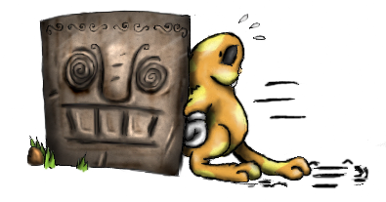
Ability – Push
Description – This diligent ta-ta has the strength to push blocks, as well as some other objects, such as frozen enemies.
NAME – #3 Tinker-Ta 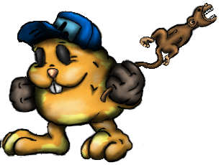
Ability – Mechanic
Description – This smart ta-ta can operate complex machinery, such as levers.
NAME – #4 Ta-Ta-Trample 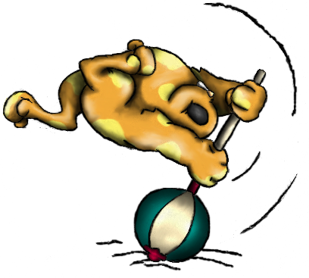
Ability – Attack
Description – This aggressive little ta is the only one brave enough to actually stand up against the mushrooms. His important attacking skill can break blocks or hurt enemy mushrooms.
NAME – #5 Hop-Ta-Hop 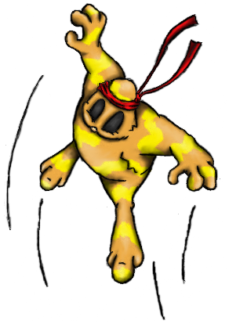
Ability – Jumper
Description – This spunky ta can jump to heights only he can reach.

NAME – #6 Frost-Ta 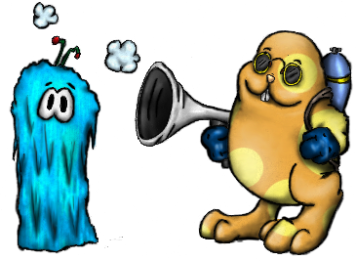
Ability – Freeze
Description – This capable ta can freeze enemy mushrooms and permanently paralyze them as well as make them push able.
NAME – #7 Para-ta-ta 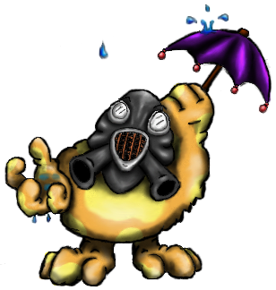
Ability – Glide, Immune to Poison Mist
Description – This advanced unit can glide through air, and is immune to poison in mist covered areas.
NAME – #8 Loop-Ta-Loop 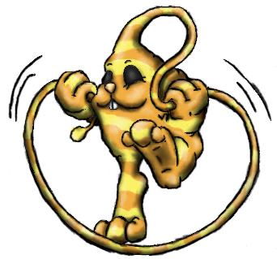
Ability – Whipper
Description – This witty ta can use his whippy head scruff to grab on to stakes and stumps and pull him self to new locations.
NAME – #9 Key-key-ta 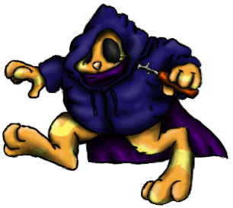
Ability – Thief
Description – This slick little ta can open up doors that are locked.
NAME – #10 Chi-Ta 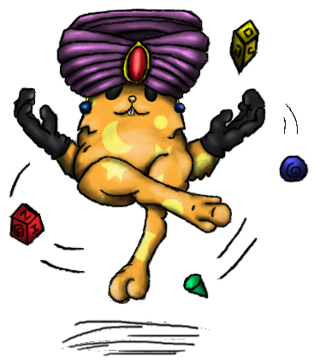
Ability – Psychic
Description – This amazing ta can levitate himself and pull objects, items and creatures to him self from any distance.
NAME – #11 Ta-Vatar 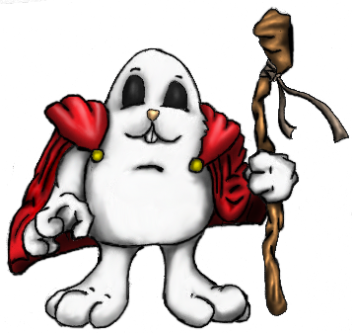
Ability – Temporata
Description – This legendary ta can warp time and space to close portals.

Enemy Design:

“Ta-Ta Mahatta” Has a total of 4 puzzle based enemies as well as 3 boss enemies. Each regular enemy can be removed by either an attack tata, a freeze tata, or an enemy can be pushed or pulled off the edge of the map. Boss fungi will have possibly 3-5 hit points which can be deducted by carefully manipulating object and character puzzle each boss contains.

Standard Enemies:

Funga-Bark.
This small vicious fungus is although unable to move, is still dangerous due to his sharp fangs.

Funga-Spy
This scary looking fungi maintains a careful look out for any passing ta-ta’s and then attacks them with his underground tentacles.

Shroom-Guard
This mushroom soldier patrols an area charging and attacking any ta-ta he sees.

Shroom-Shooter
This mushroom stump shoots out projectiles that hurt any ta-ta that it touches, but can be blocked by a defender.

Bosses:

Forest Stage – Shroom-Pa

The big boss of the forest. Shroom-Pa will be moving around the room using the waypoints. Shroom-Pa will occasionally stop and shoot a projectile upwards. Once the projectile reach high enough (vertically) then the projectile will drop down directly towards the currently selected Ta-Ta. Captain Ta-Ta needs to block the projectile and reflect it towards the boss. Once the boss is knocked out, Ta-Ta Trample needs to attack Shroom-Pa. Once attacked, Shroom-Pa will regain conscious and return to its normal movement and attack.

Mountain Stage – Catter-Shroomer.

This boss remains stationary in a random spot (using waypoint nodes). Catter-Shroom will be launching underground tentacles within an area where the currently selected Ta-Ta is. Hop-Ta-Hop needs to jump on the Catter-Shroom to knock it out. Ta-Ta Trample then needs to attack Catter-Shroom while it’s knocked out. Catter-Shroom will then dig down and go up on a new random spot. Catter-Shroom will also do this after certain duration while attacking.

Swamp Stage – Evil Mushroominoid.

The final boss will incorporate all puzzle elements in the game.

Game Play Elements:

Each level in the game will require a certain type of goal to be accomplished.

Gather ta-tas – you must get all your ta-tas to a certain spot in the level to achieve victory.

Gather Resources/Crates – get all resources/crates to a certain spot in the level to achieve victory.

Rescue Baby Ta-Tas – you must rescue these ta-tas from the clutches of Fungi and return them to a nearby shelter unscathed. Each ta-ta can only carry one baby ta-ta.

Defeat Boss – you must defeat the boss in the level to achieve victory.

There are a number of objects in the game that will be either item to be collected or acted upon to solve the puzzles.

Baby Ta-Ta – these little ta-tas are lost and must be returned to a nearby shelter. This is used in one of the goal types in the game.

Artifacts – Once collected, an artifact will be returned to the cloud level once the level is complete. Certain artifacts unlock interactions in the cloud level.

Button – A button that can be stepped on by a ta-ta to cause an effect.

Hard Button – A button that requires a block or a frozen enemy to be pushed

Lever – A mechanical lever that controls a certain object in the level.

Locked Doors – These tightly shut doors can only be opened by a thief ta-ta.

Stump/Steak – These objects can be grappled on by the Whip using ta-ta and jumped to.

Heavy Block – A block that can not be pushed and can only be broken.

Block – A block that can be pushed or broken. These can also be part of the goal in the level, whereas you must push them to the goal area.

Teleport – These transports any matter instantly to another location.

Goal – The goal area is where you must gather what is required to accomplish the level.

Signs – A small sign, tipping the player with next possible move.

What do you hope to achieve personally by creating this game?

David Dionisio:

I hope to achieve many things. Perhaps not world peace or cure for cancer, but certainly to bring happiness among the people who play this game. I would like to hear the praises of people and their agony of spending too much time playing this game.

In a technical perspective, I would like to achieve the knowledge of creating a solid 3D game. I do believe that I have accomplished many of this by now, but there are still much more to learn.

By creating this game, I hope to convince the game industry that I am capable of creating a game.

What is innovative about this game?

The game innovates in terms of gameplay. I do believe that this game incorporates third person action and puzzle solving very well. What is unique about this game is that you control more than one character in a given level, each character plays a crucial role in achieving victory. Many of the 3D games out there only have one of the two elements that this game combines: skills and brainpower. In this game, both are incorporated. Not only do you have to skillfully avoid or overcome obstacles, you must also decide on how to manage these skills to achieve victory.

What aspects of the game do you think are representative of the final product?

I do believe that the core game play is completely done. The current state of the game shows many of the game play elements that the final product will include.

The first 5 Ta-Tas are fully functional and is considered final.

All of the normal enemies are fully functional and is considered final.

Most of the menus in the game are complete, such as the main menu, new, load and the in-game options.

All of the level objects are fully functional and is shown throughout the levels included in this current state.

What areas still need work? What do you plan to do to improve those areas?

6 more Ta-Tas need to be completed and incorporated to the game.

All three of the bosses need to be completed and incorporated to the game.

2 more tutorial levels and 15 regular levels still need to be completed and incorporated to the game.

Still need to add more stuff in the cloud level, such as: artifact collection gallery, Wise Ta conversation and small interactions here and there.

Need to improve animations on some Ta-Tas and add shadows to all the objects in the game. Improving the animations can easily be fixed. The shadows can be as simple as a round circle at the bottom of the character or as complex as using projective shadows.

All sounds needs to be completed and incorporated to the game. Since the game uses a third party sound engine, most of the sound functionality has been completed. All there is to do is to create the actual sounds.

All music needs to be completed and incorporated to the game. The developer cannot create the music in the game, since he doesn’t know how to make one. Finding music on the web and contacting the author of the music to allow permission for use in the game can accomplish this task.

Options menu need to be completed and incorporated to the game. Since all the menu code has been completed, most work will be involved in incorporating the design.

The introduction and ending scene need to completed and incorporated to the game. The game scenes will make use of the scripting engine. All there is needed are art, music, sounds and the actual script for the scene.

Was this game developed as part of a school assignment, or did you develop it on your own?

This game is indeed developed as part of a school assignment, a project as a matter of fact.

